Practice test - Answer key and transcript
Answer key
Part 1.
1. C 2. C 3. A 4. A 5. C 6. B
Part 2.
7. T 8. F 9. T 10. F 11. F 12. T 13. F
Part 3.
- Artists
- 185,000
- 1,000,000
- edit
- short
- reviews
- cookbook
Transcript
Part 1
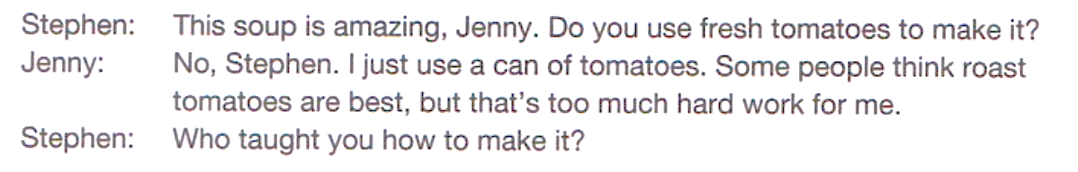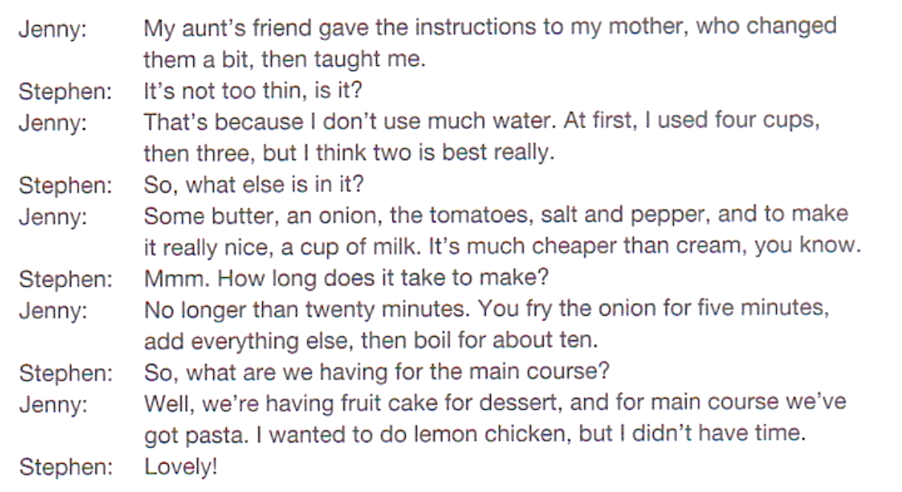
Part 2
I’ve been a professional photographer for six years. Most of my work is taking pictures for weddings and family events, but sometimes I also photograph nature or city scenes.
I usually start my day around 9 a.m., but on weekends I often begin earlier because weddings can start at 7 a.m.. On an average day, I take about 200 photos, but only 50 or 60 will be edited and sent to the client.
Being a photographer isn’t just about taking pictures. I spend a lot of time choosing locations, arranging lighting, and helping people feel comfortable in front of the camera. Sometimes children or pets are difficult to photograph, and it can take twenty or thirty minutes to get the perfect shot.
After the event, I spend several hours editing the best photos on my computer. It can be tiring, but I love seeing the finished pictures and knowing that my work makes people happy. For me, photography is not just a job — it’s a way to capture important moments in people’s lives.
Part 3
Interviewer: Today, we're talking with small business advisor, Harry Watkins, about some of the latest business trends. You all know about DIY, or Do It Yourself, where people make and repair things themselves. Well, now people are talking about Sell It Yourself. You know, Harry, in the past, when people made things, they had to look for other people to sell them or market them. Nowadays, all that is changing.
Harry Watkins: That's absolutely true. People today are more self-sufficient when it comes to starting a new business. One person can make a new product and sell it to consumers with little help from other people.
Interviewer: Can you give us an example?
Harry Watkins: Of course. One great example is what we call the indie or independent craft movement. Artists and craftspeople still sell their works at fairs and in stores, but now they are selling them online as well.
Interviewer: Can you explain how this works? It seems to me that most people don't have the skills they need to create their own websites and sell things online.
Harry Watkins: That's not really what I meant. You don't have to have your own website. You can sell through other sites that do the work for you. Here's just one example. There's a website called etsy.com. By joining etsy.com, people can sell their items online, everything from jewelry to furniture to paintings.
Interviewer: Doesn't it cost a lot?
Harry Watkins: Not when you compare it with other methods. Etsy charges a small fee for each sale, and the seller is responsible for mailing the item to the buyer. Still, sellers usually keep more of their profits this way. More than 185,000 craftspeople from all over the world sell their products on Etsy to more than a million customers. And Etsy isn't the only site. There are other similar sites.
Interviewer: Hmm. Now, that I think of it, this is happening in other areas as well. For example, in book publishing. Now, almost anyone can publish a book online.
Harry Watkins: Right. Online publishing is a good example of being self-sufficient in a new business. On some websites, you can publish your book for free.
Interviewer: For free? But how does the website make money?
Harry Watkins: Let me explain. The website takes the money from the sales and then gives a percentage of it to the author.
Interviewer: Okay. So, suppose I want to publish a book online. How do I do it?
Harry Watkins: Well, it is a big DIY project. First, you have to edit the book very carefully. Then you have to design a cover for it and write a blurb about it.
Interviewer: Excuse me. A blurb? What's that?
Harry Watkins: It's a short paragraph or two that describes the book. It has to make people want to buy it. Oh, and I almost forgot. Both craftspeople and writers have to decide on a price for their product.
Interviewer: Don't people have to promote their books? You know, put ads in magazines or on television? That can be expensive.
Harry Watkins: That's another part of the DIY process, but it's not that hard. First, people see the book on the website. That's a kind of free advertising. That's why it's important to have good covers and blurbs. Then people use social media to tell everyone they know about the book. Also, when people read the book, they write reviews to say if they liked it or not. If the book gets good reviews, more people will want to read it and so on. A friend of mine published a cookbook online.
Interviewer: A cookbook?
Harry Watkins: That's right. A cookbook with foods that are healthy and also delicious. The book is doing very well. He's even getting invitations from TV programs to come and cook some of his foods on their shows.

